CSE 2221 Midterm 1 Review Guide

Here are a list of sample questions that you might be asked on the first midterm. Questions are posed first for you to test yourself, and then the answers are given later in the document.

Java, JVM, and Eclipse

1. What does IDE stand for?
2. What is Java source code?
3. What is Java byte code?
4. What is the job of the Java compiler?
5. What does the JVM do? Include the words “loads”, “executes” and “interprets”.
6. What are some benefits of the Java Virtual Machine (JVM)?

SimpleReader, SimpleWriter, and strings

1. What is String[] args in public static void main(String[] args)?
2. Write the code to import OSU component’s SimpleWriter.
3. How do I create a SimpleWriter for the console? How do I create a SimpleWriter for a file called “file.txt”?
4. How do I create a SimpleReader for the console? How do I create a SimpleReader for a file called “file.txt”?
5. Given a SimpleReader in, how do I read a line? How do I read an integer?
6. Why should we avoid using “\n” when printing in a SimpleWriter? What is a better alternative?

Variables, operators, programming types, and mathematical types

1. Draw a picture for how a variable created like so would look: String cheer = “Go”;
2. Draw a picture for how a variable created like so would look: int j;
3. List 5 program variable types.
4. For the 5 types given in the last question, what are their corresponding mathematical types?
5. We say that every program type has a mathematical variable that ______ it.
   1. Depicts
   2. Models
   3. Codes
   4. Enumerates
6. Draw a tracing table for the following code:

int j = 5;

int i;

i = j + 2;

1. What are literals?
2. In the following lines, underline the literals.

int j = 5;

String s = “Hello”;

double d = 45.2;

int k = j + 2;

boolean b = false;

char c = ‘y’;

char e = ‘\u03c0’;

1. What keyword to we use in Java to make variables constant (i.e. non-changing)? Write a line of code as an example.
2. How do we compare if two integers, x and y, are equal?
3. How do we compare if two strings, s1 and s2, are equal?
4. How do we use AND and OR for boolean expressions?
5. Should we use == for double comparison? If no, why not?
6. What is 10 / 3? How do I find the remainder of 10 / 3?
7. Define an expression.
8. Define a statement.
9. In the following example, underline all expressions and draw a box around all statements.

SimpleWriter out = new SimpleWriter1L();

SimpleWriter in = new SimpleWriter1L();

out.print(“Enter a super cool number: “)

double userInput = in.nextDouble();

int counter = 0;

while(Math.abs(userInput) > 2){

out.println(userInput);

userInput = userInput / 2.0;

counter++;

}

out.println(userInput + “ = 2^” + counter);

1. In my main method, I have an int i = 5. But in my static method, I cannot see variable i. What vocabulary term defines this phenomenon?
2. What are 3 examples of control flow?
3. Draw a diagram for what an if statement looks like.
4. Draw a diagram for what an if-else statement looks like.
5. Draw a diagram for a while loop.
6. Trace the following while loop.

int i = 131, j = 0;

while(i > 5){

i = i / 5;

j++;

}

1. What does the while loop from the last question do to i and j (explain the math in english)?

Static methods and parameter passing

1. Write a static method that takes an integer, and returns that integer + 1.
2. Given the following method, what is the full method header?

private static int distance(int a, int b){

int c = b - a;

return c;

}

1. What is the method body of the method in the last question?
2. What is the return type of Math.pow(double a, double b)?
3. How many return statements per method do we allow in Software 1?
4. What keyword do we use when we want a static method that doesn’t return anything?
5. What are the formal parameters for the distance method given above?
6. From main:

…

int x = 5, y=10;

int z = distance(x, y)

…

What are the arguments for distance?

1. Trace through this call from main, assuming sqrt(x) returns the positive square root of x.

double x = 4;

double y = sqrt(x);

1. When a method is called primitive type arguments are _____ to the formal parameters.
   1. Copied
   2. Referenced
   3. Dereferenced
   4. Compared
2. What is the term given to how Java passes parameters to methods?

Arrays

1. How do you declare an int array of length 3?
2. How do I declare a string array without initializing it?
3. How do I access the 3rd element of an array exampleArray?
4. What is the corresponding mathematical type for arrays?
5. Write a code snippet to ask the user for the size of an array, then create an integer array of that size.
6. Write a code snippet to create an int array of length 10 and use a while loop to set every element equal to its position in the array (first = 1, second = 2, etc…)
7. Use 1 line of code to initialize a String array with elements “Go”, “Bucks”, and “OSU”.
8. Arrays in Java are __-indexed.
   1. null
   2. dictionary
   3. 0
   4. 1
9. Given an int array intArray with values 4, 1, 7, 3, what is the line of code that sets the last element to the first element plus the second element?

Design by contract

1. Define “system”.
2. What is the boundary of a system called?
3. Can systems have systems within them? If yes, what are these called?
4. What is the role of someone viewing the system from the outside?
5. What is the role of someone viewing the system from the inside?
6. What is the term for when you intentionally leave out implementation details?
7. What is another name for design by contract?
8. What is the comment above methods using /** */ called?
   1. Bracketed comment
   2. Javastyle
   3. Checkstyle comment
   4. Javadoc
9. For a given method, what dictates what the client should follow.
10. For a given method, what does the implementer need to follow?
11. What does API stand for?
    1. Apparent Program Implementation
    2. Application Program Interface
    3. Application Precondition Introduction
    4. Artificial Predetermined Issues
12. For the following method, what is sqrt(4)?

/**

* …

* @requires

* x > 0

* @ensures

* sqrt <= 0 and

* sqrt = x^(1/2)

*/

private static double sqrt(double x)

1. Given the following method, what assert statements would be a good addition to the method body?

/**

* …

* @requires

* |str1| > 0

* 0 <= index < |str1|

* …

*/

private static char charAt(String str1, int index)

Trees, XML, and XMLTree

1. What is the top node of a tree called?
2. Why is a tree considered to have a “recursive” structure?

Consider the following tree for the next questions

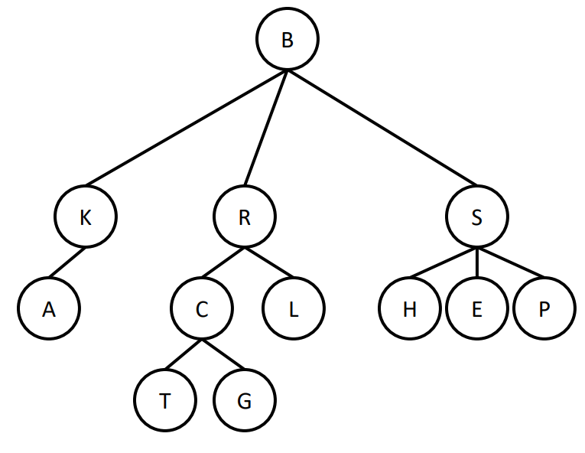

1. What is the size of the tree?
2. What is the height of the tree?
3. How many children does node A have?
4. How many children does node B have?
5. What is the path length from B to R?
6. What is the path length from R to G?
7. How many total edges are in the tree?
8. What are the sibling(s) of E?
9. What is L’s parent?
10. What are the leaf nodes?
11. How many total trees are in the tree rooted at B?
12. Select all the true statements:
    1. XML is hierarchically organized
    2. XML is compiled code
    3. XML documents can be represented with a tree
    4. XML is a specific markup language

Consider the following tree for the next questions:

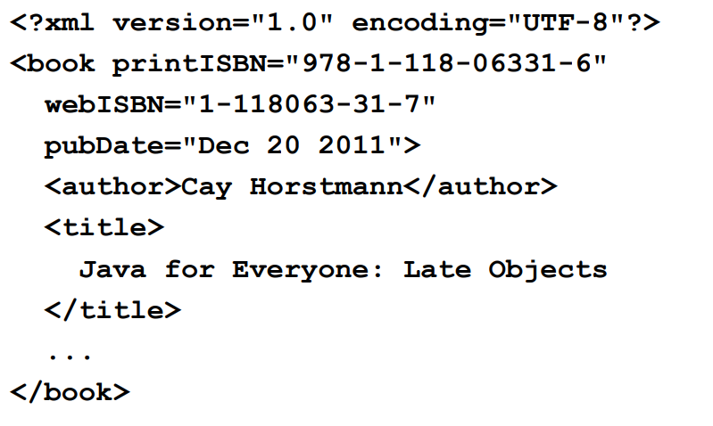

1. List all the tags that appear.
2. printISBN, webISBN, and pubDate are examples of what?
3. The line “<author>Cay Horstmann</author> is an example of what?
4. How would one finish a tag <tagName>?
5. What does a self closing tag look like?
6. True or False: All tags need to have content between them.
7. In the line “<food type=”fruit” calories=”” meal=”lunch”>, what is the value of the calories attribute?
8. Just like trees, XML has a _______ structure.
   1. Text-based
   2. Height-based
   3. Recursive
   4. Tag-based
9. Assuming we have an XML file named file.txt, how do I load that file into an XMLTree named tree?
10. What are the two kinds of nodes in an XML Tree?

The following questions are based on the tree in the picture. Assume this tree rooted at <book> is loaded into an XMLTree called tree.

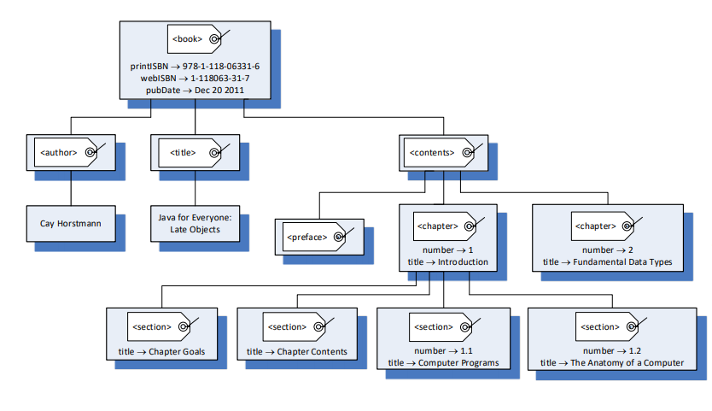

1. What expression tells me if the root node is a tag or not?
2. How do you print the value of the printISBN attribute of the <book> tag?
3. The instance method getChild(i) has what return type?
4. How would I access the <contents> child?
5. How would I read the title attribute of the first chapter child in contents?
6. Write a for loop that iterates through every child of <book> and prints the labels.
7. What is the size of the tree rooted at <book>?

Other

1. Given Random rnd = new Random1L(), how do I create a new random double between 4 and 20?
2. How do I display an image named “image.jpg” in HTML?
3. What are “magic numbers” that Checkstyle warns you about?
   1. Specific numbers that have real-world meaning.
   2. int type literals that were declared, but not as final.
   3. Any integer that could cause a runtime error.
   4. Any integer that is illegal to use in Java on its own.
4. Write the code for a static method that finds the maximum integer in an array given this header: private static int findMax(int[] a)
5. Given the following method and contract, type code within the main to repeatedly ask for a password string from a user until it meets the criteria from the method.

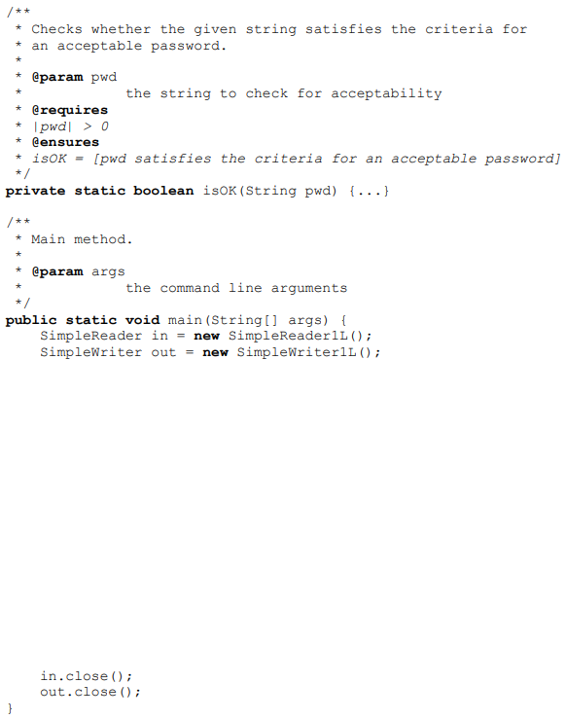

1. Draw the XML tree for the following legal XML:

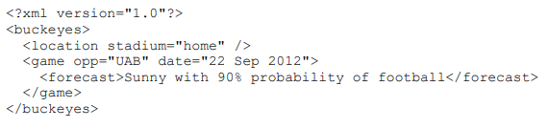

1. Which area is larger, the shaded are on the left or the shaded area on the right? Both squares are 1x1.

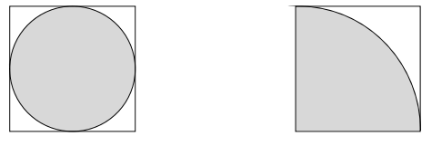

Java, JVM, and Eclipse

1. What does IDE stand for?

Integrated Development Environment

1. What is Java source code?

The code that we type in .java files

1. What is Java byte code?

Compiled java source code in a .class file

1. What is the job of the Java compiler?

To turn Java source code into Java bytecode to be ran on the JVM.

1. What does the JVM do? Include the words “loads”, “executes” and “interprets”.

The JVM loads a .class file, interprets the contents, and executes the code on the native hardware for the machine.

1. What are some benefits of the Java Virtual Machine (JVM)?

Portability: Can be written once and run just about anywhere.

Universality: Don’t have to code in Java to use the JVM. Can write in another language and compile that to Java bytecode.

Performance: Surprisingly small overhead for the JVM to run.

SimpleReader, SimpleWriter, and strings

1. What is String[] args in public static void main(String[] args)?

Command-line arguments (formal parameter is also correct but I couldn’t figure out how to word this so you only said that)

1. Write the code to import OSU component’s SimpleWriter.

import components.simplewriter.SimpleWriter;

1. How do I create a SimpleWriter for the console? How do I create a SimpleWriter for a file called “file.txt”?

Console: SimpleWriter out = new SimpleWriter1L();

File: SimpleWriter fileOut = new SimpleWriter1L(“file.txt”);

1. How do I create a SimpleReader for the console? How do I create a SimpleReader for a file called “file.txt”?

Console: SimpleReader out = new SimpleReader1L();

File: SimpleReader fileOut = new SimpleReader1L(“file.txt”);

1. Given a SimpleReader in, how do I read a line? How do I read an integer?

Line: in.nextLine();

Integer: in.nextInteger();

1. Why should we avoid using “\n” when printing in a SimpleWriter? What is a better alternative?

Newline characters depend on the operating system for the machine. \n won’t work on all machines. out.println() is a better alternative, because it uses the correct newline character at the end.

Variables, operators, programming types, and mathematical types

1. Draw a picture for how a variable created like so would look: String cheer = “Go”;
2. Draw a picture for how a variable created like so would look: int j;
3. List 5 program variable types

int, double, String, char, boolean

1. For the 5 types given in the last question, what are their corresponding mathematical types?

integers, reals, string of character, character, boolean.

1. We say that every program type has a mathematical variable that ______ it.
   1. Depicts
   2. **Models**
   3. Codes
   4. Enumerates
2. Draw a tracing table for the following code:

int j = 5;

int i;

i = j + 2;

1. What are literals?

Any data value appearing literally.

1. In the following lines, underline the literals.

int j = 5;

String s = “Hello”;

double d = 45.2;

int k = j + 2;

boolean b = false;

char c = ‘y’;

char e = ‘\u03c0’;

1. What keyword to we use in Java to make variables constant (i.e. non-changing)? Write a line of code as an example.

final.

final int TWO = 2;

1. How do we compare if two integers, x and y, are equal?

x == y

1. How do we compare if two strings, s1 and s2, are equal?

s1.equals(s2)

or

s2.equals(s1)

1. How do we use AND and OR for boolean expressions?

AND: &&

OR: ||

1. Should we use == for double comparison? If no, why not?

No. Double precision can be finicky as they get changed. We might expect a value to be 10.0, but it might be reported as 9.9999999999999999999999999999999999999.

1. What is 10 / 3? How do I find the remainder of 10 / 3?  
   10 / 3 = 3 in Java, due to integer division. We find the remainder with 10 % 3, which equals 1.
2. Define an expression.

An expression is a piece of code that has some value.

1. Define a statement.

A statement is a (smallest) complete unit of code that executes.

1. In the following example, underline all expressions and draw a box around all statements.

SimpleWriter out = new SimpleWriter1L();

SimpleWriter in = new SimpleWriter1L();

out.print(“Enter a super cool number: “)

double userInput = in.nextDouble();

int counter = 0;

while(Math.abs(userInput) > 2){

out.println(userInput);

userInput = userInput / 2.0;

counter++;

}

out.println(userInput + “ = 2^” + counter);

1. In my main method, I have an int i = 5. But in my static method, I cannot see variable i. What vocabulary term defines this phenomenon?

Scope

1. What are 3 examples of control flow?

If statements, if-else statements, for loops

1. Draw a diagram for what an if statement looks like.
2. Draw a diagram for what an if-else statement looks like.
3. Draw a diagram for a while loop.
4. Trace the following while loop.

int i = 131, j = 0;

while(i > 5){

i = i / 5;

j++;

}

1. What does the while loop from the last question do to i and j (explain the math in english)?

(5^j) + i = the original i

Static methods and parameter passing

1. Write a static method that takes an integer, and returns that integer + 1.

private static int increment(int i){

return i + 1;

}

1. Given the following method, what is the full method header?

private static int distance(int a, int b){

int c = b - a;

return c;

}

private static int distance(int a, int b)

1. What is the method body of the method in the last question?

int c = b - a;

return c;

1. What is the return type of Math.pow(double a, double b)?

double

1. How many return statements per method do we allow in Software 1?

Just 1.

1. What keyword do we use when we want a static method that doesn’t return anything?

void

1. What are the formal parameters for the distance method given above?

a and b

1. From main:

…

int x = 5, y=10;

int z = distance(x, y)

…

What are the arguments for distance?

x and y

1. Trace through this call from main, assuming sqrt(x) returns the positive square root of x.

double x = 4;

double y = sqrt(x);

1. When a method is called primitive type arguments are _____ to the formal parameters.
   1. Copied
   2. Referenced
   3. Dereferenced
   4. Compared
2. What is the term given to how Java passes parameters when methods are called?

call-by-value or call-by-copy

Arrays

1. How do you declare an int array of length 3?

int[] array = new int[3];

1. How do I declare a string array without initializing it?

String[] array;

1. How do I access the 3rd element of an array exampleArray?

exampleArray[2];

1. What is the corresponding mathematical type for arrays?

A vector

1. Write a code snippet to ask the user for the size of an array, then create an integer array of that size.

SimpleReader in = new SimpleReader1L();

SimpleWriter out = new SimpleWriter1L();

out.print(“How large should the array be: “);

int arraySize = in.nextInteger();

int[] theArray = new int[arraySize];

1. Write a code snippet to create an int array of length 10 and use a while loop to set every element equal to its position in the array (first = 1, second = 2, etc…)

int[] theArray = new int[10];

int index = 0;

while(index < theArray.length){

theArray[i] = i+1;

}

1. Use 1 line of code to initialize a String array with elements “Go”, “Bucks”, and “OSU”.

String[] stringArray = {“Go”, “Bucks”, “OSU”};

1. Arrays in Java are __-indexed.
   1. null
   2. dictionary
   3. **0**
   4. 1
2. Given an int array intArray with values 4, 1, 7, 3, what is the line of code that sets the last element to the first element plus the second element?

intArray[3] = intArray[0] + intArray[1];

Design by contract

1. Define “system”.

Any part of anything you want to think of as an indivisible unit.

1. What is the boundary of a system called?

Interface

1. Can systems have systems within them? If yes, what are these called?

Yes, they are called subsystems.

1. What is the role of someone viewing the system from the outside?

Client

1. What is the role of someone viewing the system from the inside?

Implementer

1. What is the term for when you intentionally leave out implementation details?

Information hiding

1. What is another name for design by contract?

Programming to the interface

1. What is the comment above methods using /** */ called?
   1. Bracketed comment
   2. Javastyle
   3. Checkstyle comment
   4. **Javadoc**
2. For a given method, what dictates what the client should follow.

The precondition, or @requires clause

1. For a given method, what does the implementer need to follow?

The postcondition, or @ensures clause

1. What does API stand for?
   1. Apparent Program Implementation
   2. **Application Program Interface**
   3. Application Precondition Introduction
   4. Artificial Predetermined Issues
2. For the following method, what is sqrt(4)?

/**

* …

* @requires

* x > 0

* @ensures

* sqrt <= 0 and

* sqrt = x^(1/2)

*/

private static double sqrt(double x)

-2

1. Given the following method, what assert statements would be a good addition to the method body?

/**

* …

* @requires

* |str1| > 0

* 0 <= index < |str1|

* …

*/

private static char charAt(String str1, int index)

assert str1.length > 0

assert index >= 0 && index < str1.length

Trees, XML, and XMLTree

1. What is the top node of a tree called?

The root node.

1. Why is a tree considered to have a “recursive” structure?

Because a tree is comprised of subtrees.

Consider the following tree for the next questions



1. What is the size of the tree?

12

1. What is the height of the tree?

4

1. How many children does node A have?

0

1. How many children does node B have?

3

1. What is the path length from B to R?

2

1. What is the path length from R to G?

3

1. How many total edges are in the tree?

11

1. What are the sibling(s) of E?

H and P

1. What is L’s parent?

R

1. What are the leaf nodes?

A T G H E P

1. How many total trees are in the tree rooted at B?

12

1. Select all the true statements:
   1. **XML is hierarchically organized**
   2. XML is compiled code
   3. **XML documents can be represented with a tree**
   4. **XML is a specific markup language**

Consider the following tree for the next questions:



1. List all the tags that appear.

book, author, title

1. printISBN, webISBN, and pubDate are examples of what?

attributes

1. The line “<author>Cay Horstmann</author> is an example of what?

An element

1. How would one finish a tag <tagName>?

</tagName>

1. What does a self closing tag look like?

<tagName />

1. True or False: All tags need to have content between them.

False

1. In the line “<food type=”fruit” calories=”” meal=”lunch”>, what is the value of the calories attribute?

“” - an empty string

1. Just like trees, XML has a _______ structure.
   1. Text-based
   2. Height-based
   3. **Recursive**
   4. Tag-based
2. Assuming we have an XML file named file.txt, how do I load that file into an XMLTree named tree?

XMLTree tree = new XMLTree(“file.txt”)

1. What are the two kinds of nodes in an XML Tree?

Tag and text nodes.

The following questions are based on the tree in the picture. Assume this tree rooted at <book> is loaded into an XMLTree called tree.



1. What expression tells me if the root node is a tag or not?

tree.isTag()

1. How do you print the value of the printISBN attribute of the <book> tag?

out.println(tree.attributeValue(“printISBN”))

1. The instance method getChild(i) has what return type?

XMLTree

1. How would I access the <contents> child?

tree.getChild(2)

1. How would I read the title attribute of the first chapter child in contents?

tree.getChild(2).getChild(1).attributeValue(“title”)

1. Write a for loop that iterates through every child of <book> and prints the labels.

for(int i = 0; i < tree.numberOfChildren(); i++){

out.println(tree.getChild(i).label);

}

1. What is the size of the tree rooted at <book>?

13

Other

1. Given Random rnd = new Random1L(), how do I create a new random double between 4 and 20?

4 + 16*rnd.nextDouble();

1. How do I display an image named “image.jpg” in HTML?

<img src=”image.jpg” />

1. What are “magic numbers” that Checkstyle warns you about?
   1. Specific numbers that have real-world meaning.
   2. **int type literals that were declared, but not as final.**
   3. Any integer that could cause a runtime error.
   4. Any integer that is illegal to use in Java on its own.
2. Write the code for a static method that finds the maximum integer in an array given this header: private static int findMax(int[] a). You can assume a has at least 1 element.

private static int findMax(int[] a){

int max = a[0];

for(int i = 0; i < a.length; i++){

if(a[i] > max){

max = a[i];

}

}

return max;

}

1. Given the following method and contract, type code within the main to repeatedly ask for a password string from a user until it meets the criteria from the method.



boolean validPassword = false;

while(!validPassword){

out.print(“Enter a password: “);

String tempPassword = in.nextLine();

validPassword = isOK(tempPassword);

}

1. Draw the XML tree for the following legal XML:



1. Which area is larger, the shaded are on the left or the shaded area on the right? Both squares are 1x1.



They are the same! Area of circle is pi*r^2. Left_area = pi * 1^2 = pi. The right area is one quarter of a circle with radius 2. Then Right_area = (pi * 2^2) / 4 = (4 * pi) / 4 = pi. Then Left_area = Right_area.